QUESTION NO 01:

#include <stdio.h>

int main() {

int number, sum = 0;

printf("Enter numbers to add to the sum (enter 0 to stop):\n");

while (1) {

printf("Enter a number: ");

scanf("%d", &number);

if (number == 0) {

break;

}

sum += number;

printf("Current sum: %d\n", sum);

}

printf("Final sum: %d\n", sum);

return 0;

}

Output:

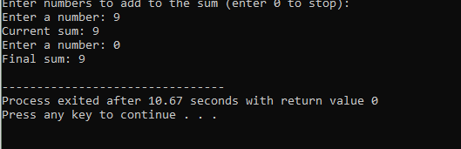

QUESTION NO 02:

#include<stdio.h>

int main()

{

int n,i,flag=1;

printf("\nENTER THE NUMBER : ");

scanf("%d",&n);

if (n==1)

{

flag=0;

}

else{

for(i=2;i<n-1;i++){

if(n%i==0)

{

flag=0;

break;

}}

}

{

if(flag==1){

printf("it is prime\n");

}

else{

printf("it is not prime\n");}

}

Output:

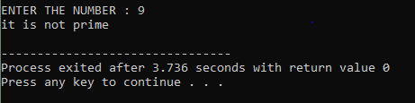

Question no 03:

#include<stdio.h>

int main()

{

int num=0, i, j, next;

printf("\n enter the number:");

scanf("\n%d",&num);

printf("%d\n",i);

while(i<num)

{

printf("%d\n",j);

next=i+j;

i=j;

j=next;

}

}

Output:

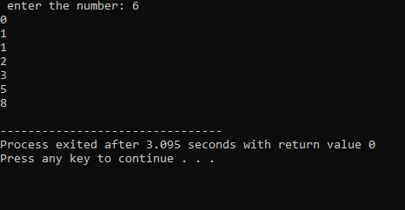

Question no 04

#include<stdio.h>

int main()

{

int num,n,digit1,sum=0;

printf("\nENTER THE NUMBER : ");

scanf("%d",&num);

n=num;

while(num!=0)

{

digit1=num%10;

sum=sum+digit1\*digit1\*digit1;

num=num/10;

}

printf("%d",sum);

if(sum==n)

{

printf("is armstrong");

}

else{

printf("is not armstrong"); }

}

Output:

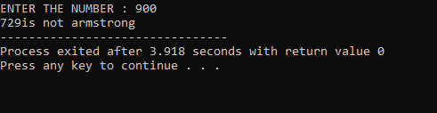

Question no 05:

#include <stdio.h>

int main()

{

int i, j, n = 6;

for (i = 1; i <= n; i++)

{ for (j = 1; j <= 5; j++)

{ if (i == 1 || i == n || j == 1 || j == 5)

{ printf(" \*");

}

else {

printf(" "); }

}

printf("\n"); }

return 0;

}

output:

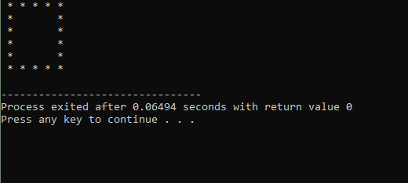

Question no 06:

#include<stdio.h>

int main()

{ char x='\*';

int i=0;

printf("%c %c\n",x,x);

do

{ printf("%c %c %c %c %c\n",x,x,x,x,x);

i++;

}

while(i<4);

printf("%c %c\n",x,x);

}

Ouput:

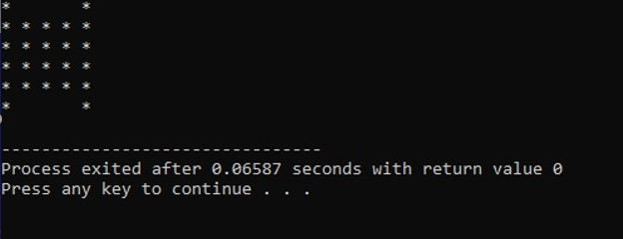

Question no 07:

#include<stdio.h>

int main()

{

int rows=6,i;

char start='A';

for(i=1;1<=rows;i++)

{ if(i==1)

{ printf("A B C D E\n");

}

else if(i==2){

printf("B F\n");

}

else if(i==3){

printf("C G\n");

}

else if(i==4)

{ printf("D H\n");

}

else if(i==5)

{ printf("E G\n");

}

else if(i==6)

{ printf("F G H I J\n");

}

}

}

Output:

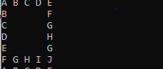

Question no 08:

#include<stdio.h>

int main()

{ int rows=5,i;

for(i=1;i<=rows;i++)

{

if(i==1)

{

printf("A B C D E\n");

}

else if(i==2)

{ printf(" C F\n");

}

else if(i==3)

{ printf(" E\n");

}

else if(i==4)

{ printf(" E F\n");

}

else if(i==5)

{ printf("E F G H I\n");

}

}

return(0);

}

Output:

